**Gracious Germents**

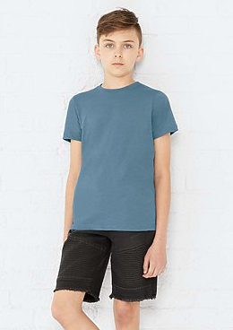

**DESCRIPTION:**

LAT™ Youth 100% Combed Ringspun Cotton Contrast Back Fine Jersey Tank

The comfort of a tee in a fashionable tank! These contrast back tanks will look great layered or worn alone while the contrasting colors give you the stylish comfort you crave!

Fabrication: 4.5 oz. 100% combed ringspun cotton fine jersey (Ash is 98/2; CVC Colors are 60/40; Heather is 90/10 combed ringspun cotton/polyester)

Features: Contrast self-fabric binding on neck and armholes • Contrast back panel and forward shoulder piecing • Coverstitched bottom hem • Side seam construction • EasyTear™ label

Care: Machine washable/ tumble dry low

Safety: CPSIA compliant tracking label in side seam

Fit: Youth Unisex

Note: Color descriptions indicate Front/Back and Shoulder colors, e.g. Ash/Heather indicates Ash front with Heather back and shoulders.

**ADDITIONAL INFORMATION**

Weight: 0.5 kg

Dimensions: 10 × 8 × 3 cm

Size: S, M, L, XL,

Price: $20.00